Name: Karthik Shivaa

Screenshot:

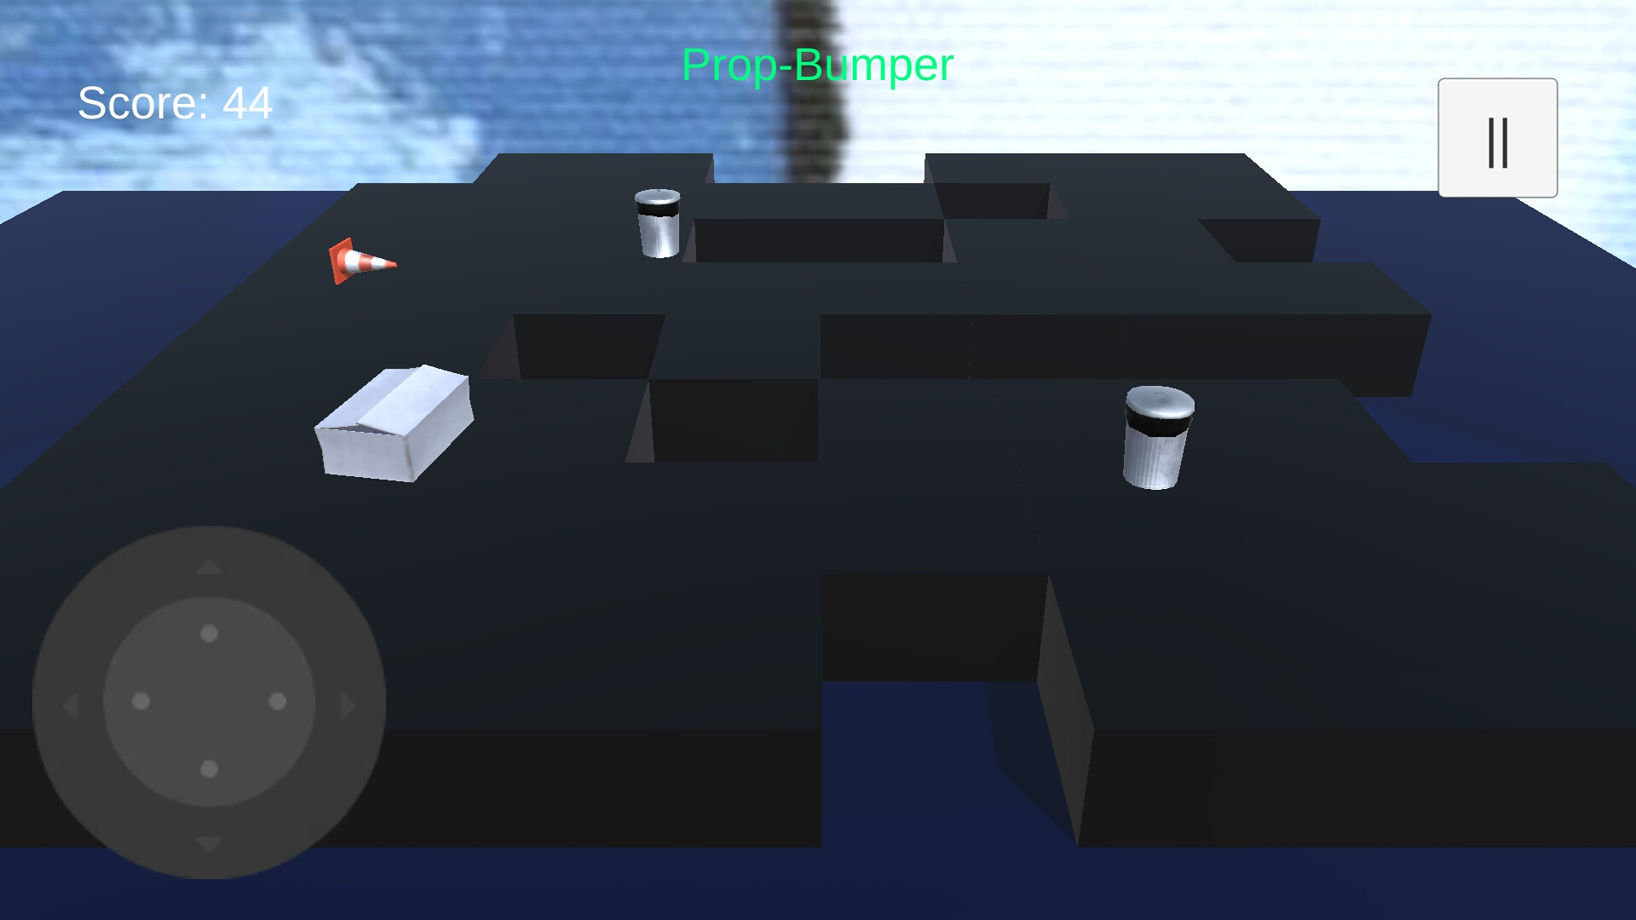

PropBumper:

The game is focused on the box (player) trashing the AI back. The player controls the box using the virtual controller. The direction of the player is specified with the player pointer. On player collision with AI, and vice versa, based on acceleration, a force is exerted on the object. The platform that the game is set on rises with time. The difficulty for the game is set up through two mechanics. The platform that the game is set on loses random pieces, keeping the gameplay fresh. The number of enemies in the level gradually increases over time, leading to rising difficulty. The player is awarded points for each second that they are alive on the field. Every enemy AI that is successfully knocked off the play area awards a point of 10.

Future development:

AI mode – Multiple boxes compete with a time limit to gain maximum score

Different AI models and masses

Special powers for the player